H.T No
Regulations:
A15

Sreenidhi Institute of Science and Technology
(An Autonomous Institution)
Code No: 5BC03 Date: 30-Aug-2023 (FN)

B.Tech I-Year II- Semester External Examination, Aug/Sept-2023 (Supplementary)
ENGINEERING MECHANICS (CIVIL and ME)

Time: 3 Hours Max.Marks:75 Note: a) No additional answer sheets will be provided.
b) All sub-parts of a question must be answered at one place only, otherwise it will not be valued.
c) Missing data can be assumed suitably.

Bloom's Cognitive Levels of Learning (BCLL)
Remember | L1 | Apply | L3 | Evaluate | L5
Understand | L2 | Analyze | L4 | Create | L6

Part - A Max.Marks:25

Answer all QUESTIONS.
 |  | BCLL | CO(s) | Marks
1 | State and prove parallelogram law of forces. | L1 | CO1 | [2M]
2 | What is the advantage of method of section over method of joints. | L1 | CO2 | [2M]
3 | Define angle of friction and angle of repose. | L1 | CO3 | [2M]
4 | Write down the position of centroid of the quarter circle. | L1 | CO4 | [2M]
5 | Define the terms angular velocity and angular acceleration | L1 | CO5 | [2M]
6 | State and derive the work-energy principle. | L1 | CO6 | [3M]
7 | State triangle law of forces and polygon law of forces. | L1 | CO1 | [3M]
8 | State and prove the theorem of perpendicular axis applied to moment of inertia. | L1 | CO4 | [3M]
9 | Define the terms ‘collision of elastic bodies’. Discuss the phenomenon of collision. | L1 | CO6 | [3M]
10 | What are the assumptions made, while finding out the forces in the various members of a framed structure ? | L1 | CO2 | [3M]

Part – B Max.Marks:50
ANSWER ANY FIVE QUESTIONS. EACH QUESTION CARRIES 10 MARKS.

 |  |  | BCLL | CO(s) | Marks
11. |  | Two identical rollers, each of weight W=1000 N, are supported by an inclined plane and a vertical wall as shown in Fig.1. Find the reactions at the points of supports A, B and C. assume all the surfaces to be smooth.  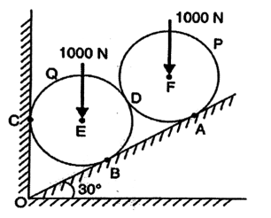 | L3 | CO1 | [10M]
12. |  | Find the force acting in all members of the truss shown in Figure2  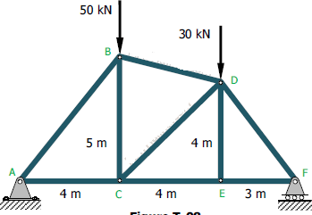 | L3 | CO2 | [10M]
13. |  | Locate the centroid of the shaded area shown in figure 3  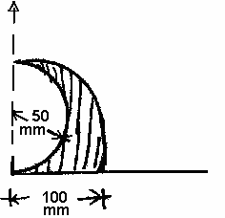 | L3 | CO3 | [10M]
14. |  | Determine the mass moment of inertia of sphere about its diametrical axis | L4 | CO4 | [10M]
15. |  | A projectile fired from the edge of a 150 m high cliff with an initial velocity of 180 m/s at an angle of elevation of 30° with the horizontal. Neglecting air resistance find :  1. The greatest elevation above the ground reached by the projectile ; and  2. Horizontal distance from the gun to the point, where the projectile strikes the ground. | L3 | CO5 | [10M]
16. |  | Two bodies weighing 300N and 450N are hung to the two ends of a rope passing over an ideal pulley as shown in fig. With what acceleration will the heavier body come down? What is the tension in the string? | L3 | CO6 | [10M]
17. | a) | Prove that the angle of repose is equal to the angle of friction. | L3 | CO1 | [4M]
 | b) | A block overlaying a 10⁰ wedge on a horizontal floor, leaning against a vertical wall, and weighing 2000 N is to be raised by applying a horizontal force to the wedge as shown in figure 4. Assuming coefficient of friction for all contact surfaces is 0.25, determine the minimum horizontal force to be applied to raise the block.  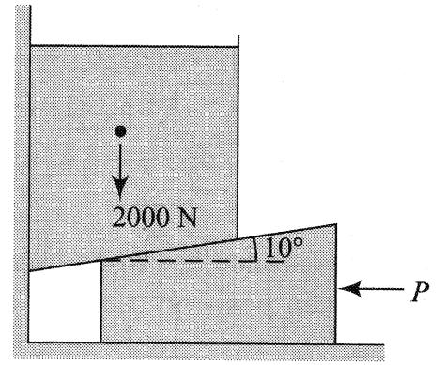 | L4 | CO2 | [3M]
 | c) | Define polar moment of inertia. | L1 | CO3 | [3M]
18. | a) | State and explain transfer formula for mass moment of inertia. | L1 | CO4 | [4M]
 | b) | State D’Alembertz Principle. | L1 | CO5 | [3M]
 | c) | Define the terms: Time of accent, time of decent, time of flight, projectile, horizontal range, work & power. | L1 | CO6 | [3M]

-- 00 -- 00 –

